Ex.no:4b | EXPLORATORY DATA ANALYSIS (EDA) – DATA INSPECTION, FILTERING, STATISTICAL ANALYSIS AND CORRELATION

AIM

To perform data inspection, filtering, sorting, grouping, aggregation, descriptive statistical analysis, and correlation analysis on the Fashion Products Analysis dataset using Pandas, and to visualize the analytical results using Matplotlib.

ALGORITHM
Algorithm 1: Dataset Inspection
- Import the Fashion Products Analysis dataset.
- Display the first few records of the dataset.
- Check the dimensions of the dataset.
- Display the data types of the attributes.
- Generate a statistical summary of the numerical attributes.
Algorithm 2: Filtering Data
- Select the required attribute
- Specify a suitable filtering condition.
- Apply the condition to the dataset.
- Display the filtered records.
Algorithm 3: Sorting Data
- Select the attribute
- Apply the sort_values() function.
- Specify the sorting order.
- Display the sorted dataset.
Algorithm 4: Statistical Analysis
- Select the required numerical attribute.
- Calculate the mean.
- Calculate the median.
- Calculate the mode.
- Calculate the standard deviation.
- Display the calculated statistical measures
Algorithm 5: Grouping and Aggregation
- Select a categorical attribute
- Apply the groupby() function.
- Select the required numerical attribute
- Calculate an aggregate measure such as mean or sum.
- Display the grouped results.
Algorithm 6: Correlation Analysis
- Select the required numerical attributes
- Apply the corr() function.
- Generate the correlation matrix.
- Analyze the correlation coefficient between the selected attributes.
- Visualize the relationship using an appropriate graph.

CODE
import pandas as pd
import numpy as np
import matplotlib.pyplot as plt
import seaborn as sns
from google.colab import files

uploaded = files.upload()
csv_file = list(uploaded.keys())[0]
print("Uploaded File:", csv_file)

df = pd.read_csv(csv_file, encoding="latin1", low_memory=False)
print("\nDataset Loaded Successfully")
print("\nFirst 5 Rows:")
print(df.head())
print("\nLast 5 Rows:")
print(df.tail())
print("\nDataset Shape:")
print(df.shape)
print("\nColumn Names:")
print(df.columns)
print("\nData Types and Information:")
df.info()

print("\nProducts with Price greater than 5000:")
print(df[df["Price"] > 5000][["Product ID","Product Name","Brand","Category","Price","Rating"]].head())

print("\nProducts with Rating greater than 4:")
print(df[df["Rating"] > 4][["Product ID","Product Name","Brand","Category","Price","Rating"]].head())

print("\nProducts Sorted by Price:")
print(df.sort_values(by="Price", ascending=False)[["Product Name","Brand","Category","Price","Rating"]].head(10))

print("\nProducts Sorted by Rating:")
print(df.sort_values(by="Rating", ascending=False)[["Product Name","Brand","Category","Price","Rating"]].head(10))

print("\nAverage Price by Brand:")
print(df.groupby("Brand")["Price"].mean().sort_values(ascending=False))

print("\nAverage Rating by Category:")
print(df.groupby("Category")["Rating"].mean().sort_values(ascending=False))

print("\nProduct Count by Brand:")
print(df.groupby("Brand")["Product ID"].count().sort_values(ascending=False))

print("\nCategory Count:")
print(df["Category"].value_counts())

print("\nDescriptive Statistical Analysis:")
print(df[["Price","Rating"]].describe())

print("\nMinimum and Maximum Price:")
print("Minimum Price:", df["Price"].min())
print("Maximum Price:", df["Price"].max())

print("\nCorrelation Matrix:")
correlation_matrix = df[["Price","Rating"]].corr()
print(correlation_matrix)

plt.figure(figsize=(8,5))
df["Brand"].value_counts().plot(kind="bar")
plt.title("Number of Products by Brand")
plt.xlabel("Brand")
plt.ylabel("Number of Products")
plt.xticks(rotation=45)
plt.show()

plt.figure(figsize=(8,5))
df["Category"].value_counts().plot(kind="bar")
plt.title("Number of Products by Category")
plt.xlabel("Category")
plt.ylabel("Number of Products")
plt.xticks(rotation=45)
plt.show()

plt.figure(figsize=(8,5))
plt.hist(df["Price"], bins=20)
plt.title("Distribution of Product Prices")
plt.xlabel("Price")
plt.ylabel("Frequency")
plt.show()

plt.figure(figsize=(8,5))
plt.boxplot(df["Price"].dropna())
plt.title("Box Plot of Product Prices")
plt.ylabel("Price")
plt.show()

plt.figure(figsize=(8,5))
plt.scatter(df["Price"], df["Rating"])
plt.title("Price vs Rating")
plt.xlabel("Price")
plt.ylabel("Rating")
plt.show()

print("\nTop 10 Products by Price:")
print(df.nlargest(10, "Price")[["Product Name","Brand","Category","Price","Rating"]])

print("\nTop 10 Products by Rating:")
print(df.nlargest(10, "Rating")[["Product Name","Brand","Category","Price","Rating"]])

print("\nUnique Brands:")
print(df["Brand"].unique())

print("\nUnique Categories:")
print(df["Category"].unique())

print("\nNumber of Unique Brands:", df["Brand"].nunique())
print("Number of Unique Categories:", df["Category"].nunique())

df.to_csv("Fashion_Products_Analysis_Output.csv", index=False)
print("\nOutput file exported successfully.")

print("\nFashion Products Analysis completed successfully.")
OUTPUT:
First 5 Rows:
User ID Product ID Product Name Brand Category Price Rating \
0 19 1 Dress Adidas Men's Fashion 40 1.043159
1 97 2 Shoes H&M Women's Fashion 82 4.026416
2 25 3 Dress Adidas Women's Fashion 44 3.337938
3 57 4 Shoes Zara Men's Fashion 23 1.049523
4 79 5 T-shirt Adidas Men's Fashion 79 4.302773

Color Size
0 Black XL
1 Black L
2 Yellow XL
3 White S
4 Black M

Last 5 Rows:
User ID Product ID Product Name Brand Category Price \
995 20 996 Shoes Zara Women's Fashion 55
996 42 997 Sweater Nike Kids' Fashion 13
997 9 998 Sweater Zara Men's Fashion 47
998 8 999 T-shirt Zara Women's Fashion 68
999 91 1000 Shoes Adidas Women's Fashion 79

Rating Color Size
995 1.620081 Black M
996 1.544464 Green L
997 3.961913 White L
998 3.089722 Blue S
999 3.093553 White L

Dataset Shape:
(1000, 9)

Column Names:
Index(['User ID', 'Product ID', 'Product Name', 'Brand', 'Category', 'Price',
'Rating', 'Color', 'Size'],
dtype='object')

Data Types and Information:
<class 'pandas.core.frame.DataFrame'>
RangeIndex: 1000 entries, 0 to 999
Data columns (total 9 columns):
# Column Non-Null Count Dtype
--- ------ -------------- -----
0 User ID 1000 non-null int64
1 Product ID 1000 non-null int64
2 Product Name 1000 non-null object
3 Brand 1000 non-null object
4 Category 1000 non-null object
5 Price 1000 non-null int64
6 Rating 1000 non-null float64
7 Color 1000 non-null object
8 Size 1000 non-null object
dtypes: float64(1), int64(3), object(5)
memory usage: 70.4+ KB

Products with Price greater than 5000:
Empty DataFrame
Columns: [Product ID, Product Name, Brand, Category, Price, Rating]
Index: []

Products with Rating greater than 4:
Product ID Product Name Brand Category Price Rating
1 2 Shoes H&M Women's Fashion 82 4.026416
4 5 T-shirt Adidas Men's Fashion 79 4.302773
7 8 Sweater Zara Kids' Fashion 64 4.360303
8 9 Sweater H&M Men's Fashion 53 4.466182
9 10 T-shirt Zara Kids' Fashion 55 4.093234

Products Sorted by Price:
Product Name Brand Category Price Rating
937 T-shirt Gucci Kids' Fashion 100 3.217890
268 Shoes H&M Kids' Fashion 100 4.743391
737 Jeans H&M Men's Fashion 100 1.033843
868 Jeans Zara Men's Fashion 100 1.839079
91 Jeans Adidas Men's Fashion 100 1.845071
711 Shoes Gucci Kids' Fashion 100 4.610942
435 T-shirt Zara Kids' Fashion 99 2.822618
559 Dress Adidas Women's Fashion 99 1.002064
649 Dress Gucci Women's Fashion 99 4.309090
788 Jeans Nike Women's Fashion 99 2.514205

Products Sorted by Rating:
Product Name Brand Category Price Rating
501 Dress Zara Kids' Fashion 33 4.987964
417 Jeans Zara Men's Fashion 34 4.986091
578 Shoes Gucci Women's Fashion 57 4.985950
198 T-shirt Zara Women's Fashion 15 4.980656
703 T-shirt Adidas Kids' Fashion 38 4.979678
969 Sweater H&M Kids' Fashion 19 4.976832
990 Shoes Nike Kids' Fashion 25 4.972677
641 T-shirt Gucci Kids' Fashion 22 4.965199
887 Sweater Gucci Kids' Fashion 73 4.953446
36 Sweater Zara Kids' Fashion 48 4.947665

Average Price by Brand:
Brand
Nike 57.570093
H&M 57.567010
Gucci 55.429319
Zara 54.748768
Adidas 53.515152
Name: Price, dtype: float64

Average Rating by Category:
Category
Kids' Fashion 3.034457
Women's Fashion 2.999432
Men's Fashion 2.941697
Name: Rating, dtype: float64

Product Count by Brand:
Brand
Nike 214
Zara 203
Adidas 198
H&M 194
Gucci 191
Name: Product ID, dtype: int64

Category Count:
Category
Kids' Fashion 351
Women's Fashion 327
Men's Fashion 322
Name: count, dtype: int64

Descriptive Statistical Analysis:
Price Rating
count 1000.000000 1000.000000
mean 55.785000 2.993135
std 26.291748 1.153185
min 10.000000 1.000967
25% 33.000000 1.992786
50% 57.000000 2.984003
75% 78.250000 3.985084
max 100.000000 4.987964

Minimum and Maximum Price:
Minimum Price: 10
Maximum Price: 100

Correlation Matrix:
Price Rating
Price 1.000000 0.033927
Rating 0.033927 1.000000
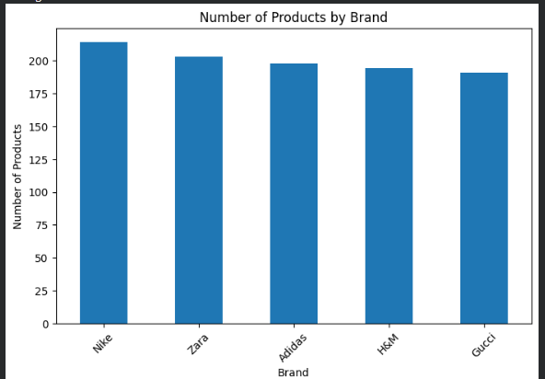
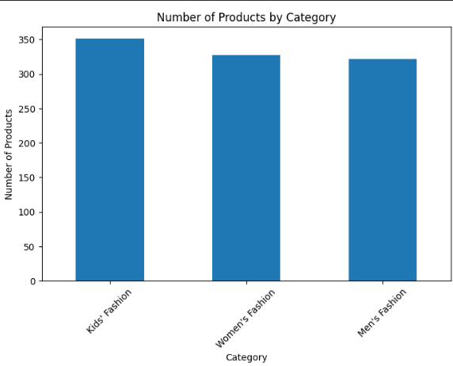

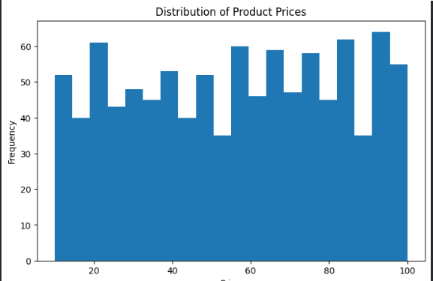
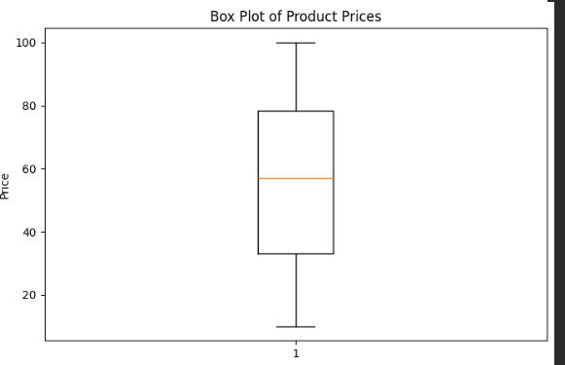
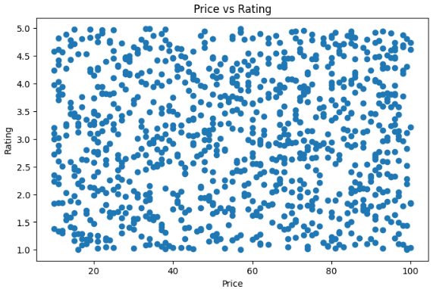

Top 10 Products by Price:
Product Name Brand Category Price Rating
91 Jeans Adidas Men's Fashion 100 1.845071
268 Shoes H&M Kids' Fashion 100 4.743391
711 Shoes Gucci Kids' Fashion 100 4.610942
737 Jeans H&M Men's Fashion 100 1.033843
868 Jeans Zara Men's Fashion 100 1.839079
937 T-shirt Gucci Kids' Fashion 100 3.217890
29 Sweater Nike Kids' Fashion 99 3.110114
435 T-shirt Zara Kids' Fashion 99 2.822618
559 Dress Adidas Women's Fashion 99 1.002064
585 Sweater Nike Kids' Fashion 99 2.280076

Top 10 Products by Rating:
Product Name Brand Category Price Rating
501 Dress Zara Kids' Fashion 33 4.987964
417 Jeans Zara Men's Fashion 34 4.986091
578 Shoes Gucci Women's Fashion 57 4.985950
198 T-shirt Zara Women's Fashion 15 4.980656
703 T-shirt Adidas Kids' Fashion 38 4.979678
969 Sweater H&M Kids' Fashion 19 4.976832
990 Shoes Nike Kids' Fashion 25 4.972677
641 T-shirt Gucci Kids' Fashion 22 4.965199
887 Sweater Gucci Kids' Fashion 73 4.953446
36 Sweater Zara Kids' Fashion 48 4.947665

Unique Brands:
['Adidas' 'H&M' 'Zara' 'Gucci' 'Nike']

Unique Categories:
["Men's Fashion" "Women's Fashion" "Kids' Fashion"]

Number of Unique Brands: 5
Number of Unique Categories: 3

Output file exported successfully.

Fashion Products Analysis completed successfully.

RESULT

